Name: Ali Albayrak

Student ID: P304320

Random Integer Report Test Documentation

Test Table:

As the numbers are generated by randomly, I wanted to see the number of occurrence for each number separately. So, we can test the chart more easily.

Test Number 1:

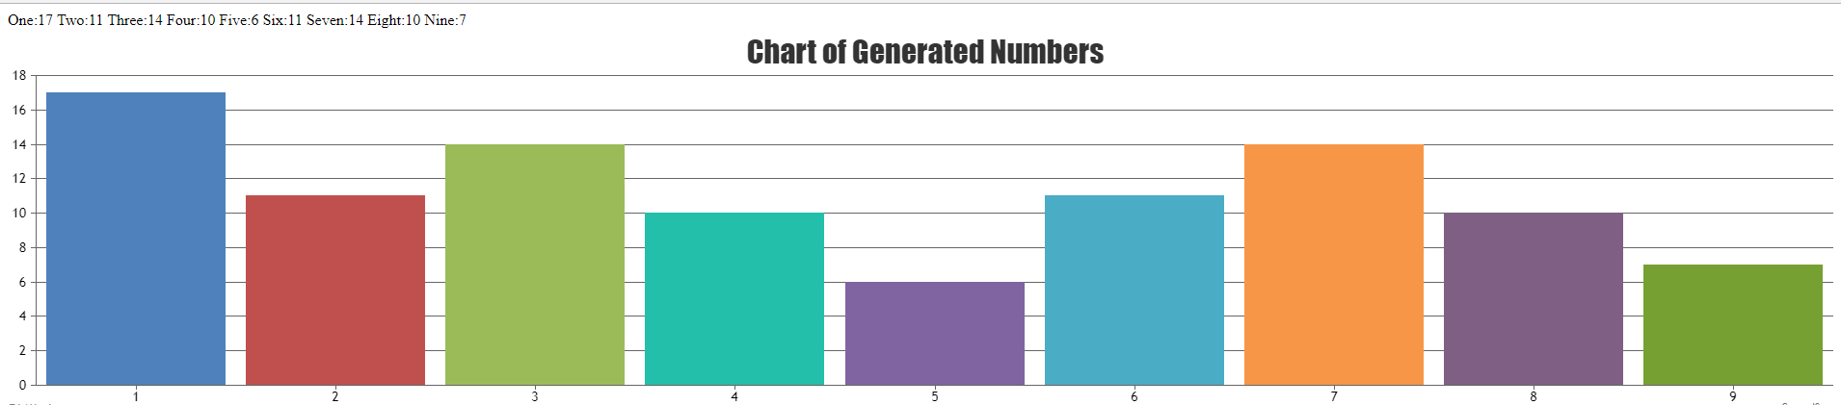

As we can see from the upper side of the screenshot,

number One:17 times, number Two:11 times, number Three:14 times, number Four:10 times, number Five:6 times, number Six:11 times, number Seven:14 times, number Eight:10 times and number Nine:7 times occurred. When we examine the chart, we can see the results are correct as expected.

Test Number 2:

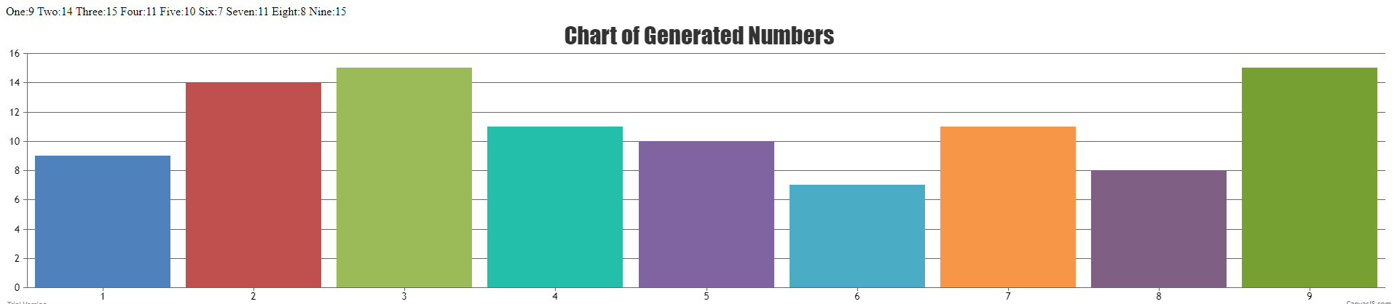

As we can see from the upper side of the screenshot,

number One:9 times, number Two:14 times, number Three:15 times, number Four:11 times, number Five:10 times, number Six:7 times, number Seven:11 times, number Eight:8 times and number Nine:15 times occurred. When we examine the chart, we can see the results are correct as expected.

Php code tested on chrome:

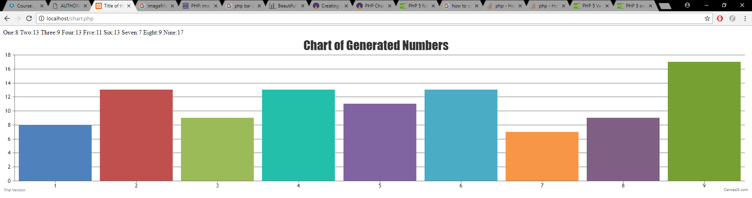

Php code tested on mozilla:

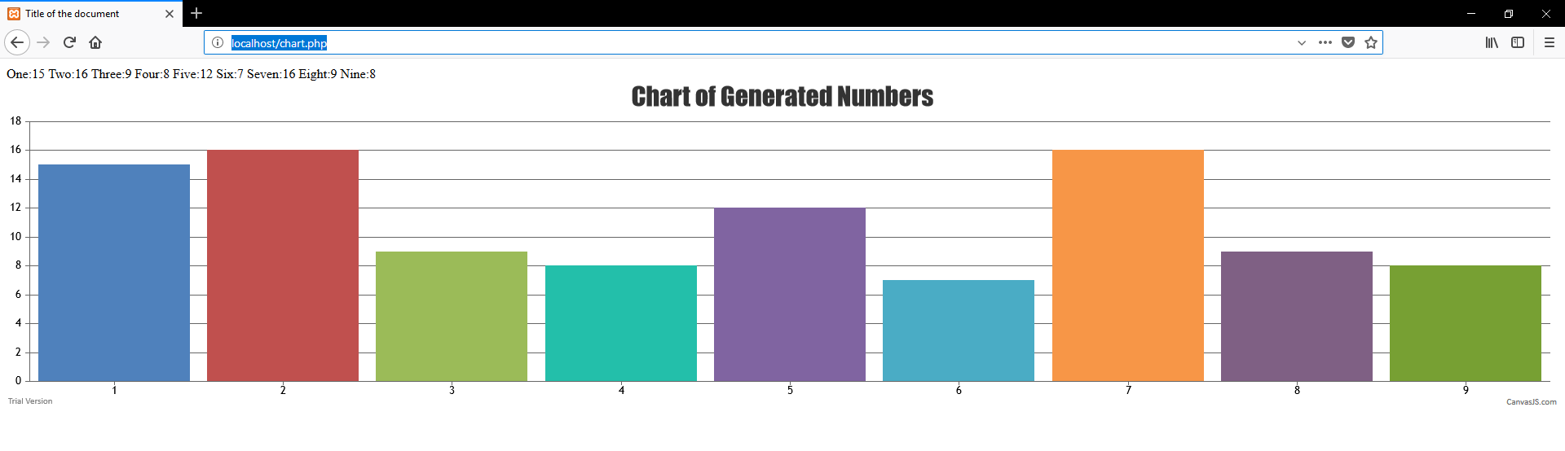

Php code tested on internet explorer:

